**Week 5 Final Project: Student Portal Landing, Login, and Enrollment Pages**

Heather Seymour

University of Arizona Global Campus

CST 499 Capstone for Computer Software Technology

Charmelia Butler

January 27, 2025

**Figure 1: Landing Page for Non-Logged-In User**

**Description:** The Landing Page shown in **Figure 1** serves as the default view for non-logged-in users, providing options to log in or register for the Student Portal.

**Figure 2: Landing Page (Dashboard) for Logged in User**

**Description:** The Landing Page, shown in **Figure 2**, serves as a dashboard for logged-in users, allowing them to view recent notifications, their current courses, and access options to view or register for new courses. Additionally, the top navigation menu updates dynamically, providing logged-in users with options to log out of the system or update their profile information for a personalized experience.

**Figure 3: Login Page**

**Description:** The Login Page shown in **Figure 3** facilitates user authentication by allowing registered users to log in to the Student Portal.

**Figure 4: Enrollment Page**

**Description:** The Enrollment Page shown in **Figure 4** enables logged-in users to view all available courses, enroll in open courses, and join the waitlist for courses that are full. The course list provides a clear display of the current number of enrolled students and the maximum enrollment capacity for each course. These values are dynamically updated in real-time as students enroll, unenroll, or join the waitlist, ensuring accurate and up-to-date information.

**Figure 5: Registration Page**

**Description:** The Registration Page shown in **Figure 5** allows a new user to register for the student portal using their email address, and other student data.

**Figure 6: Profile Page**

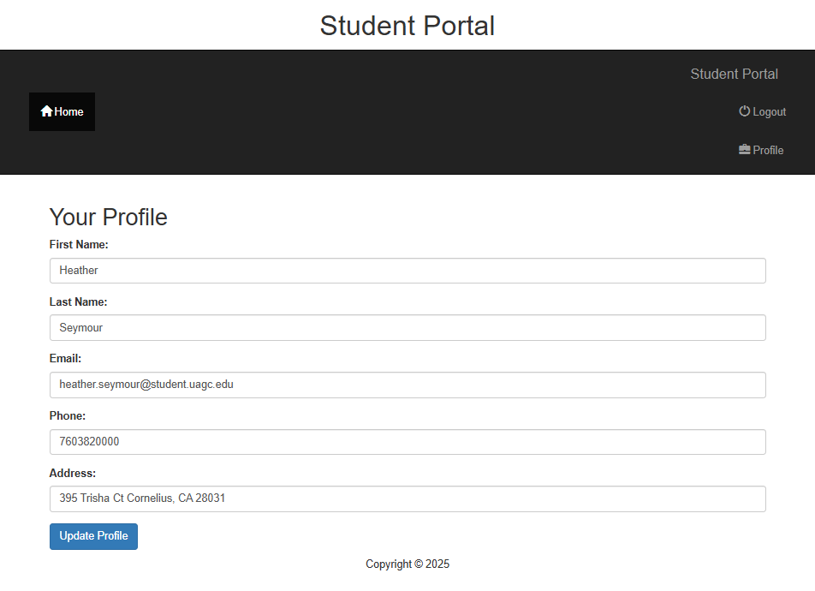

**Description: Figure 6** displays the Profile Page which enables logged-in users to update their personal information, including name, email, phone number, and address. Changes made to this form are seamlessly updated in the Student Portal database.